**Elemental Fox**

# Game Description

Elemental Fox is a 2D platformer and puzzle game where the player needs to resolve puzzles and avoid enemies by using different forms and powers.

The player can change the appearance and the abilities of the character during the gameplay by interacting with a elemental obelisk to complete the level.

The player can access 5 elemental forms (fire, water, earth, air and neutral) each element interacts in a different way with the traps and mechanisms, also every element has a active and a passive ability:

* Passive ability: Will interact with the environment just by being in a given place
* Active ability: Will be used when the player presses **“E”**

The player can also carry one single object to complete the puzzle while he caries a object the player can not use his active skill.

While the majority of the traps and mechanisms will either permit the player to pass, kill him or make him lose some progress, some of them may reveal hidden paths or present different challenges. The traps and mechanisms can also be specific for a element or have different variants for every element.

Enemies will need to be either avoided or used as steeping stones for the player to progress, with the combat being non existent instead the player needs to outsmart or completely avoid the enemies.

# Character

## Description

### General

The general aspect of the character is that of a fox with two tails, with a black patch of fur at the end of each tail.

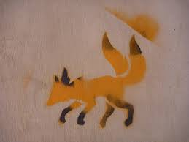 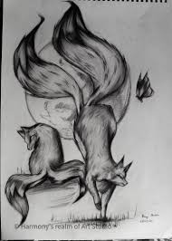

The character will have 5 forms with every form having different sprites, animations, stats and abilities.

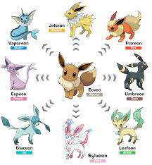 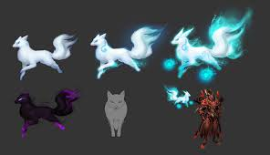

### Pre-transformation neutral

Pre-transformation is the form that will be presented in the first half of the Level 1, having the same design as the neutral form but missing the second tail. Stats are identical with the neutral form missing the active and passive ability.

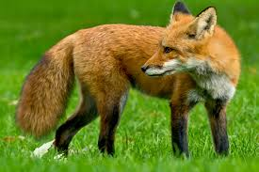

### Neutral

In neutral form the sprite will be that of a red fox with two tails, black fur present at the end of each tail, on the lower part of each foot and on the ears.

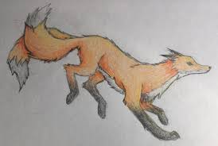

Animations:

* Walk
* Jump
* Idle
* Idle(AFK)

### Fire

In fire form the character colors change to a fiery red, with flames present on the tails and on the ears, with the sprites giving an agile aspect.

 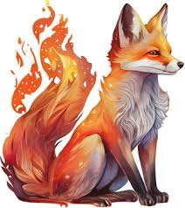

Animations:

* Walk
* Jump

### Water

In water form the basis tails are switch with fish tails that end in a fin, with the tails keeping the same length. The color of the body changes to a blue/dark blue, with water droplets permanently falling from the body and droopy ears giving the player the feeling that the character can melt at any time.

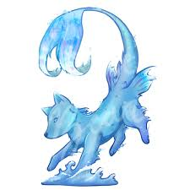 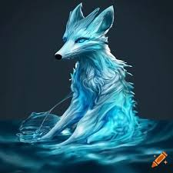

Animations:

* Walk
* Jump

### Earth

In earth form the character presents scales across the body, with the majority concentrated around the shoulder, ribcage and on the head forming a helmet, making the character appear hard and sturdy as a rock, but also a slow mover. The tails become covered in stone taking the aspect of a mace.

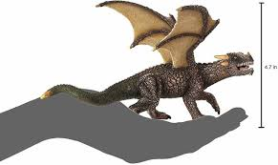 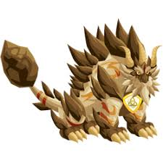

Animations:

* Walk
* Jump

### Wind

In wind form the character has a floaty appearance similarly to that of a ghost, with the lower part of the legs being translucent giving the feeling that the character floats above the ground, and the tails missing the base making them float near the character.

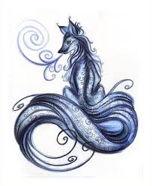 

Animations:

* Walk
* Jump

## Stats

### General

The world is formed from small cubes and all the measurements will be in rapport with the cubes, for an easier understanding every cube will have the dimensions 1m x 1m.

The character hit box dimensions will be 1,8 m in length and 1,7 m in height, with the hole sprite taking almost a 2m x 2m in diameter.

Red: standard block 1x1

Blue: character sprite 2x2

|  |  |  |  |  |  |  |  |
| --- | --- | --- | --- | --- | --- | --- | --- |
|  |  |  |  |  |  |  |  |
|  |  |  |  |  |  |  |  |
|  |  |  |  |  |  |  |  |
|  |  |  |  |  |  |  |  |
|  |  |  |  |  |  |  |  |
|  |  |  |  |  |  |  |  |

### Neutral

Stats:

* Walk - 6m/s
* Jump - 4 m
* Falling - 30% increase in gravity

### Fire

Stats:

* Walk - 8m/s
* Jump - 6m
* Falling - 30% increase in gravity

### Water

Stats:

* Walk - 6m/s
* Jump - 4m
* Falling - 30% increase in gravity

### Earth

Stats:

* Walk - 4m/s
* Jump - 2M
* Falling - 50% increase in gravity

### Wind

Stats:

* Walk - 6m/s
* Jump - 8m
* Falling - 0% increase in gravity

## Elemental Power

### General

Elemental power is a passive ability that will affect the player, the environment or both.

### Neutral

### Fire

Fire passive gives the player the ability to wall jump and walk on lava blocks

### Water

Water passive gives the player the ability to walk on water blocks

### Earth

Earth passive gives the player the ability to not be affected by a large variety of traps

### Wind

Wind passive gives the player a higher jump and the ability to jump and walk on special cloud blocks.

## Elemental Ability

### General

Elemental ability is activated when the player presses “E”

### Neutral

### Fire

The player shoots a ball of fire that will burn the first object that it interacts with.

### Water

Once activated the player can move up any stream of water ow waterfall.

### Earth

Once activated the player can push boxes and terrain elements around the map.

### Wind

Once activated the player will generate a powerful wind that will push the player up.

## Controls

### Mouse and Keyboard

A/D - Left/Right

Space - Jump

E - Interact/Pick object/Active ability

### Controller

Left stick left/right - Left/Right

A - Jump

Y - Interact/Pick object/Active ability

# Camera

## General

Camera will have 4 areas areas with the character being placed in the middle:

1. White area – the player can move around in the white area, the camera will not follow the player or change positions

Camera speed – **0m/s**

1. Green area – once the player enters the green area camera will slowly move towards the player

Camera speed – **2m/s**

1. Yellow area – once the player enters the yellow area camera will move towards the player

Camera speed – **4m/s**

1. Red area – once the player enters the red area camera will move rapidly towards the player

Camera speed – **6m/s**

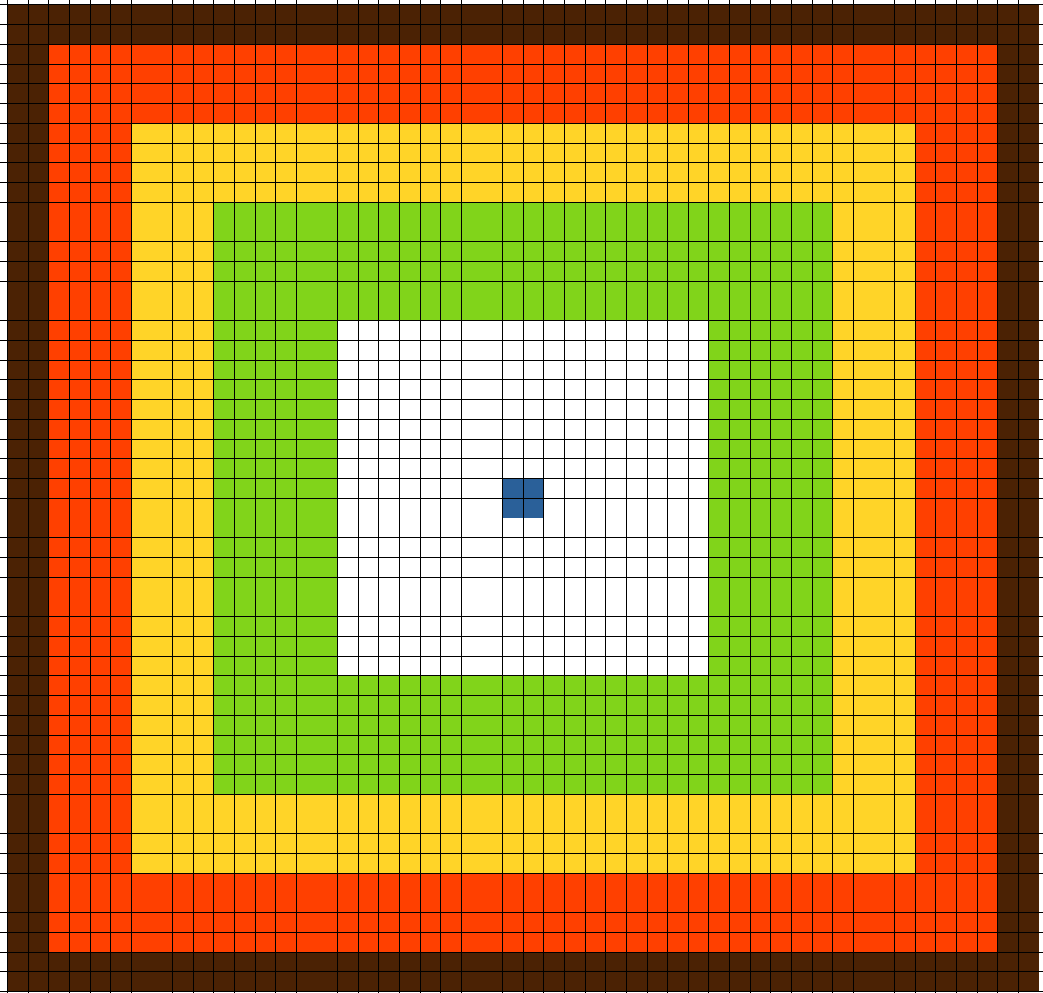

## Camera Effects

# Environment

## Levels

### Level 1 – Ancient Forest

The first level serves as a tutorial and an introduction of the game world being one of the shortest levels in the game, also teaches the player controls, avoiding obstacles and activating mechanisms and introduces the layer to the lore of the game.

Level theme is that of a European rain-forest with lush and green moss, crooked trees with moss on their branches and a slight mist that covers the background tiles.

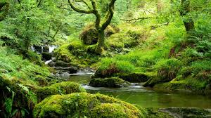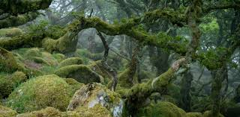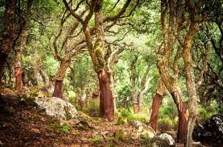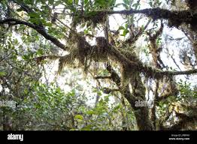

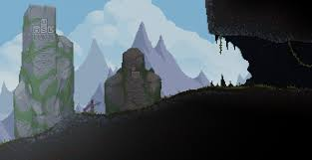

After the game starts controls are presented in a similar mode to Noita where the controls appear in the background but are easily observed by the player. The first hint (Move – WASD) appears right as the player opens the level, the next hint (Jump – Space) will appear right before the player is forced to perform a jump, the third hint is placed where the player needs to interact with the great altar **(TBD – power being infused, animations and effects)**

### Level 2 – Tree base

## Enemies

## Mechanisms

### Obelisk

The obelisk



### Altar

The altar is a mechanism found at level 1, when interacted with will trigger a cut-scene where the player is infused with elemental energy and transformed into the neutral form. Altar can be interacted only once starting the cinematic.

The altar has the shape of a half pyramid with the altar on top of it and surrounded by four (non intractable) Obelisks each one of them having a different element represented, with lush moss, branches and wines growing all around it, and a light ray shining in the middle of it.

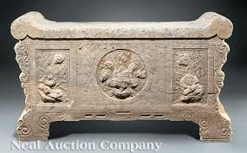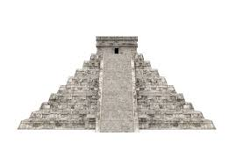

Altar background



Altar

### Burning block

Burning block is a piece of wood that can be light up and destroyed using Fire elemental ability

### Info stone

A stone that provides the player with hints and information's, will light up when the player is near it.

### Broken Obelisk

A obelisk that is heavily damage, the player can not use this obelisk to transform.

### Trigger

A trigger for animations and events

### Moving platform

A platform that moves on a predestined path

## Traps

### Spikes

Spikes are a fully stationary trap that will damage the player every time he steps on it. The spikes can be placed on floors, walls and ceilings.

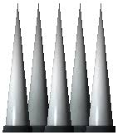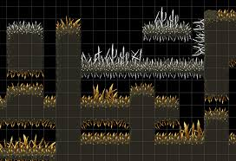

Spikes can have different sprites based on the on the map:

* sticks
* wood

### Retractable Spikes

Retractable spikes are a variant of the normal spikes that will retract and then push out on a set time interval. The player can safely cross while the spikes are retracted and gets hurt while they are pushed out.

### Trigger spikes

Trigger spikes are a variant of spikes that will stay hidden until the player gets closer and then will activate.

### Crumbling block

Blocks will break after 5 seconds from when the player steps on it.

### Dropping leaf

Dropping leaf has the same behavior as the Crumbling block but instead of dissapearing it will shrivel and after 4 seconds will regain power and return to the original form.

### Shallow water

A small layer of water, only affects the Fire element.

# Combat

## Health

# Economy

# Interface

## Start Menu

## UI

## Pause Menu

# Graphics and sound

## Graphics

## Sound